MORE INFORMATION

Utah Department of Public Safety
For the full text of the law, safety resources, and the Personal Electric Vehicle Safety Certificate course:
dps.utah.gov
recreation.utah.gov
Utah Code Reference
Title 41, Chapter 6a
HB 381 (2026) — Electric Mobility Device Amendments

This pamphlet is for informational purposes only. Always consult the full text of Utah Code for complete legal requirements.

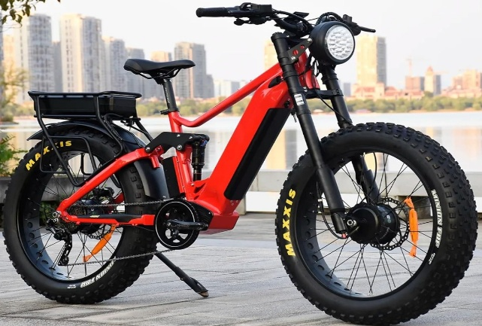

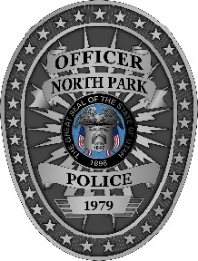
A PUBLIC SAFETY GUIDE FROM
North Park Police Department
2575 N 600 E
North Logan, Utah
nppdut.gov
435-753-7600

QUICK REFERENCE

About This Law
Utah House Bill 381 — the Electric Mobility Device Amendments — updates Utah law to cover the growing use of electric bicycles, electric motorcycles, and motor-assisted scooters.
This pamphlet summarizes what riders, parents, and the public need to know to stay safe and legal.
Effective Dates
May 6, 2026 — Most provisions take effect
May 5, 2027 — Safety education program begins
- Available as an online course at www.recreation.utah.gov
- Administered by Dept. of Public Safety

Three Device Categories
- Electric Bicycles (E-Bikes) Classes 1, 2, and 3
- Electric Motorcycles — high-power electric cycles
- Motor Assisted Scooters — stand-up e-scooters

UNIVERSAL RULES
• Helmet required on highways if under 21
• No alcohol consumption while riding
• No freeway operation
• No tampering with factory equipment
• Local ordinances may add restrictions

Violations
Most violations are classified as infractions. A peace officer may hold the device if the rider is under 18.

UTAH
Electric Mobility Device
LAW

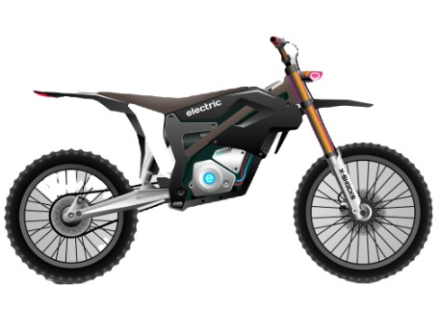

HB 381
Electric Mobility Device Amendments

EFFECTIVE MAY 6, 2026

ELECTRIC BICYCLE
(E-BIKE)
What Is an E-Bike?
A bicycle with an electric motor (max 750 watts), fully operable pedals, and which can be ridden without the motor.
E-BIKE CLASSES
Class 1: Pedal-assist only; cuts off at 20 mph.
Class 2: Throttle-powered; cuts off at 20 mph.
Class 3: Pedal-assist only; cuts off at 28 mph; requires speedometer.
Programmable: Switches between Class 1, 2, or 3 modes. Requires permanently affixed, operable cranks.
WHERE YOU CAN RIDE
- Bicycle lanes on public highways
- Paths and trails designated for bicycles
- Roads and streets open to bicycles
- Multi-use pathways (local rules may apply)
Treated as a bicycle — no driver license or registration required for age 16+.
AGE REQUIREMENTS
Under 8: Cannot operate with motor on a highway.
Ages 8–15: Requires DIRECT parent supervision OR Safety Certificate.
Age 16+: May operate without supervision.
HELMET & PENALTIES
Under 21: Helmet required on highways.
No-helmet fine: Up to $25.
Violations: Infraction; a peace officer may hold the bike if the rider is under 18.
ELECTRIC BICYCLE RESTRICTED USES
- No operating on freeways
- No alcohol consumption while riding — Class C Misdemeanor
- No tampering with motor or electronics beyond factory settings
- No riding where bicycles are prohibited
- Trails prohibited by federal law or conservation easement are off-limits
- Local authorities may restrict use on sidewalks, paths, or trails

ELECTRIC MOTORCYCLE
HIGH-POWER ELECTRIC CYCLE
What Is an Electric Motorcycle?
A motorcycle powered by an electric motor that is EITHER:
- More than 750 watts, OR
- Capable of exceeding 20 mph on motor power alone
- Has no manufacturer-installed cranks
- Uses throttle-controlled acceleration
OHV Education Course required.
ON TRAILS / PUBLIC LAND
Typically treated as off-highway vehicles (OHVs); must follow OHV regulations.
- Only on designated motorized trails and routes
- Follow rules for public lands where motorized use is allowed
ON PUBLIC ROADS
Must meet street-legal motorcycle requirements, including:
- Title and registration
- Valid driver's license & motorcycle endorsement
- Insurance
- Required safety equipment (lights, mirrors, horn, signals)
LICENSE & AGE
Required: Valid Class D license AND motorcycle endorsement. Safety Certificate if under 18.
Under 16: Cannot operate on a highway/public road.
Age 16+: Valid Class D license with a motorcycle endorsement, or the OHV safety certificate.
Under 21: Helmet required on highways.
SAFETY CERTIFICATE
Riders under 18 must obtain a Personal Electric Vehicle Safety Certificate.
- Online course at recreation.utah.gov
ELECTRIC MOTORCYCLE RESTRICTED USES
- No freeways without proper licensure
- No alcohol while operating — Class C Misdemeanor
- No lane splitting between moving lanes
- No passing in the same lane as overtaken vehicle
- Cannot attach to another vehicle on roadway
- No tampering beyond manufacturer settings

MOTOR ASSISTED SCOOTER
STAND-UP E-SCOOTER
What Is a Motor Assisted Scooter?
A self-propelled device with:
- At least two wheels
- Electric motor not exceeding 2,000 watts
- Handlebars and a standing or sit/straddle deck
- Maximum 20 mph on a level surface
Treated as a bicycle under Utah law. No driver license required.
WHERE YOU CAN RIDE
- Roads and streets open to bicycles
- Bicycle lanes on public highways
- Across roadways in crosswalks (not negligently)
AGE REQUIREMENTS
Under 8: Cannot operate with motor running on a highway.
Ages 8–15: Requires DIRECT parent supervision OR Safety Certificate.
Age 16+: May operate without supervision.
Owner liability: Cannot permit riders under 16 to violate these rules.
SAFETY CERTIFICATE
Riders ages 8–15 without direct supervision must obtain a Personal Electric Vehicle Safety Certificate.
- Online course at recreation.utah.gov
- Fee: $10 or less — Dept. of Public Safety
HELMET & PENALTIES
Under 21: Helmet required on highways.
Exception: Rented Class 1 scooters from businesses are exempt.
No-helmet fine: Up to $25.
Violations: Infraction; officers may hold scooters if rider is under 18.
MOTOR ASSISTED SCOOTER RESTRICTED USES
- No freeways or public parking structures
- No riding where bicycle use is prohibited
- Cannot exceed 15 mph
- No more riders than designed for
- No mechanical/structural alterations from factory
- No alcohol while riding — Class C Misdemeanor

